Imports

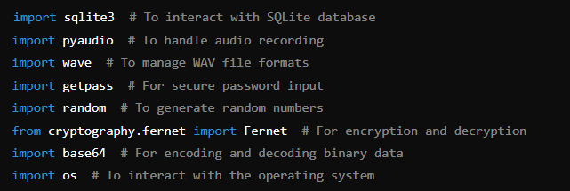

These imports include necessary libraries for database management, audio recording, encryption, and general operations.

Encryption Functions

Generate Encryption Key

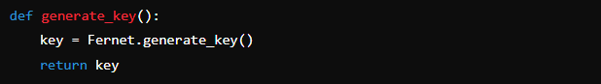

This function generates a new encryption key using Fernet.

Save Encryption Key

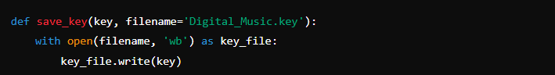

This function saves the generated key to a file.

Load Encryption Key

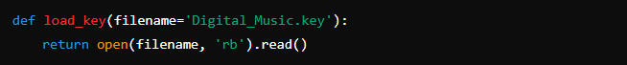

This function loads the encryption key from a file.

Encrypt Message

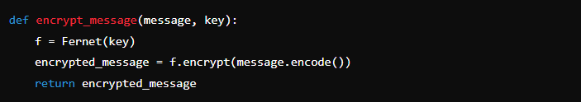

This function encrypts a message using the given key.

Decrypt Message

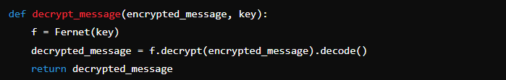

This function decrypts an encrypted message using the given key.

Key Management

Check if Key Exists

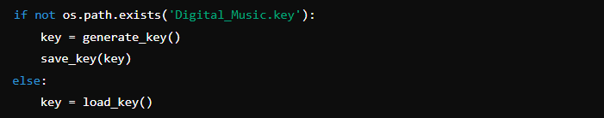

This part checks if the encryption key file exists. If not, it generates a new key and saves it; otherwise, it loads the existing key.

Database Setup

Setup Database

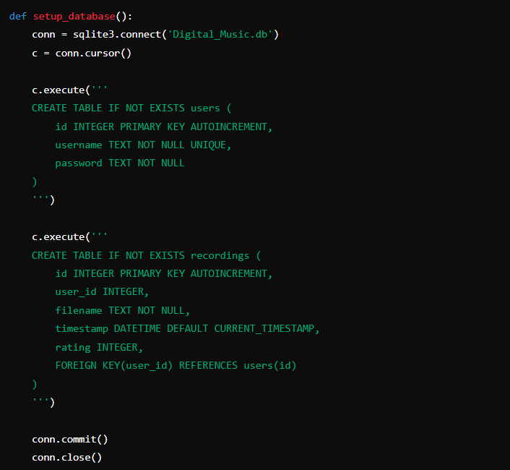

This function sets up the SQLite database with users and recordings tables.

User Registration

Register User

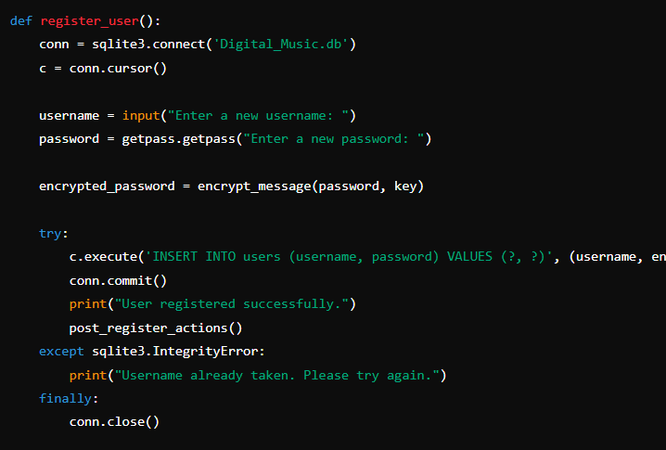

This function registers a new user by prompting for a username and password, encrypting the password, and saving the details to the database.

Post Register Actions

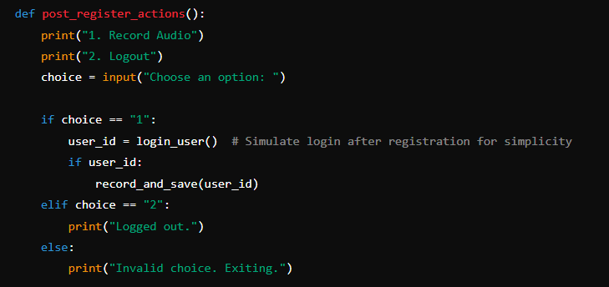

This function handles actions immediately after user registration, such as recording audio or logging out.

User Login

Login User

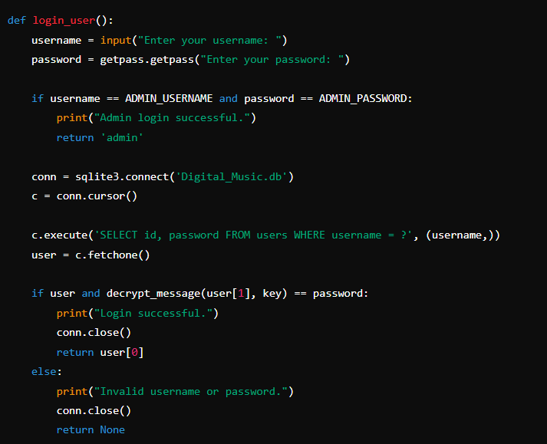

This function handles user login by verifying the username and password. If the admin credentials are used, it returns 'admin'.

Viewing Recordings

View User's Recordings

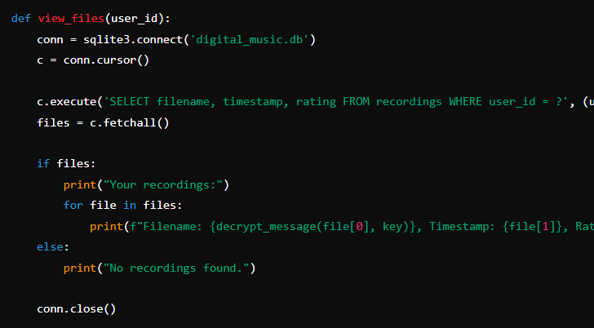

This function retrieves and displays a user's recordings from the database

View All Recordings (Admin)

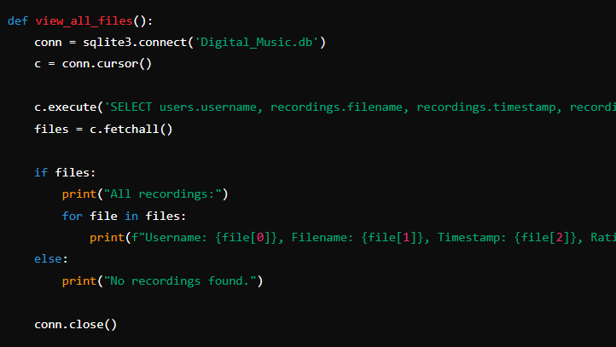

This function allows the admin to view all recordings from all users.

Managing Recordings

Delete Recording (Admin)

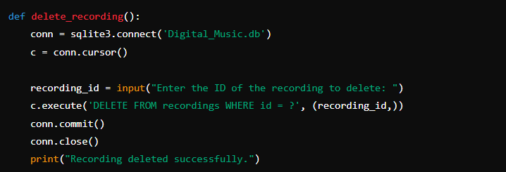

This function allows the admin to delete a recording by its ID.

Record Audio

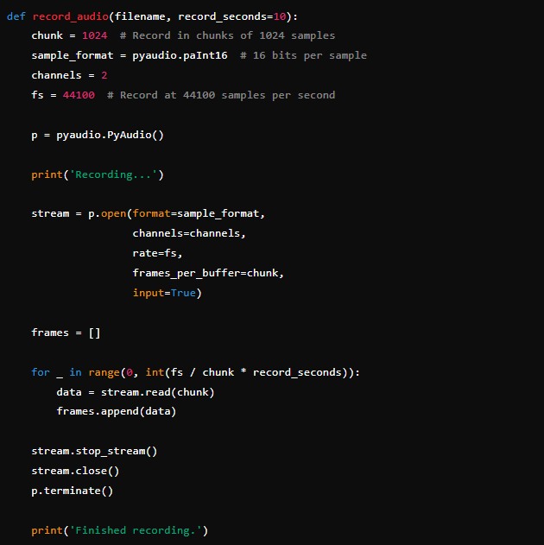

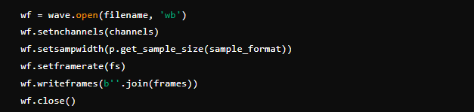

This function handles audio recording and saves the recorded audio to a file.

Save Recording Metadata

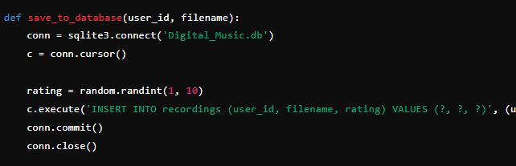

This function saves recording metadata (user ID, filename, and rating) to the database.

Record and Save

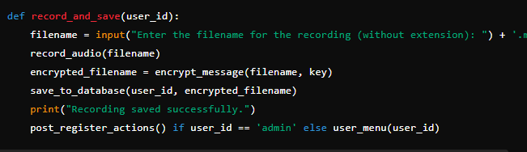

This function handles the entire process of recording audio, encrypting the filename, and saving it to the database.

User and Admin Menus

User Menu

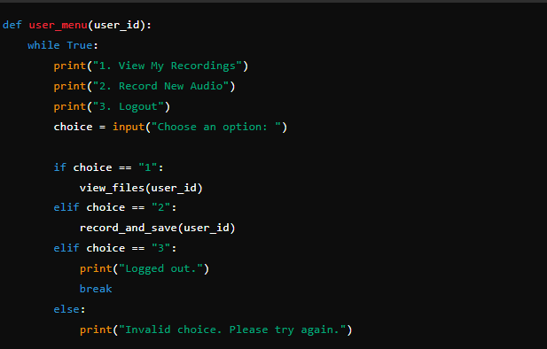

This function displays the user menu with options to view recordings, record new audio, or log out.

Main Function

Main Function

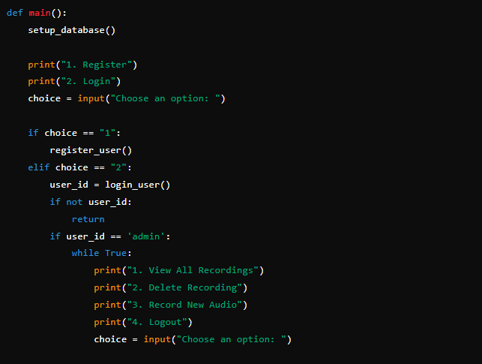

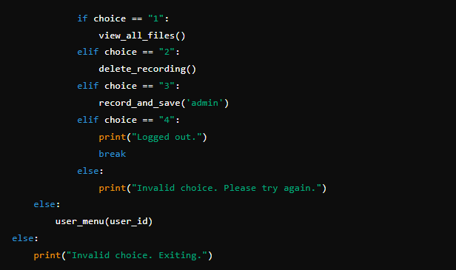

This is the main function that starts the application. It sets up the database and provides initial options to register or log in.

Run Main Function



This ensures that the main() function is called when the script is run directly.